**TEACHER’S TEST HOSTING PLATFORM**

This is a Desktop app for teachers to create tests for students to attempt remotely as Self-assessments.

This document will walk through step by step on how to get started and use this platform affectively.

# Technical Details

The Backend language used for this platform is Python 3.7.6 using Tkinter built-in Library for the Graphical User Interface.

The Database for this application is kept online at Google Firebase. It’s centralized and accessible universally.

# Brief Description

There are 2 ends to this application. A teachers’ platform and a Students’ platform, where the Teacher can create tests for students to be attempted, while the Student Side of the application only reads from the Database to render and display the tests on a any Computer System, remotely connected to the Internet, which the students can use as their self- assessments to the lessons provided by the Teacher.

See next page for installation guide.

# Installation Guide

1. Open the following link to go to the Software repository.

<https://www.dropbox.com/sh/mwiqu7d20yy8ljd/AADbAsJTUwDXNxuhyIZtgz8Ja?dl=0>

1. Click on Download > Direct Download as shown:

1. Wait for the download to finish (progress seen on bottom po-up.

1. After successfully downloaded, click on the arrow next to “Teacher Platform.zip”, then click on “Show in Folder”

1. (Optional) Move the folder to any specific location of your choice. Suppose I placed it in “MyFolder”

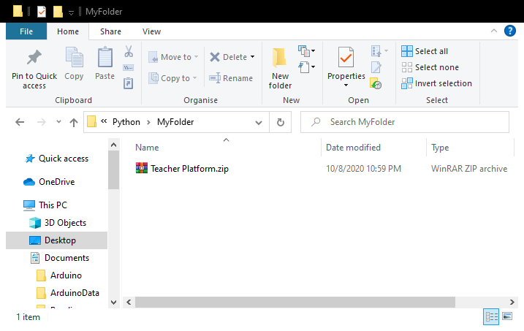

1. Right click on the File and click “Extract here”

1. **DO NOT TAMPER WITH ANY FILE or FOLDER OF THE PROJECT!**
2. Launch setup by double click setup(.exe)

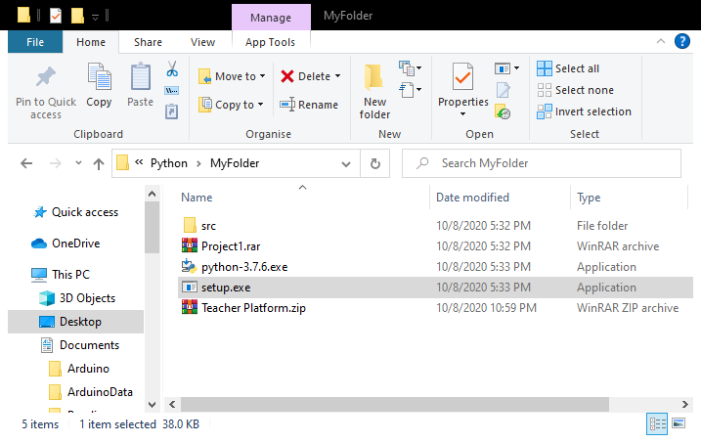

1. Follow the Python 3.7.6 setup wizard. (I have already installed so I get different options.)

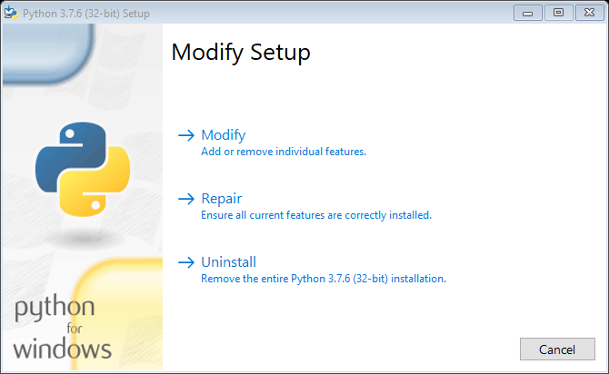

1. After successful installation, you will see “TeacherPlatform(.exe)” file in your main application folder (MyFolder in this example) and it will be automatically launched.

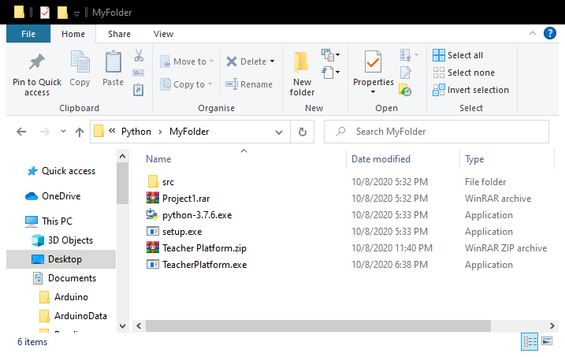

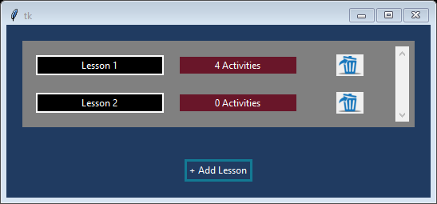

# Keys and general guidelines for the Software

Here 2 examples lessons have been added.

Below are some general guidelines for this app.

1. The Blue Dustbin icon against any row will be there as a delete option for the corresponding item (Lesson or Activity)
2. Black Boxes are used for names (Lessons or Activities), click them to update the name.
3. Anywhere where you see a hand curor (like in the image below), that box or image is clickable and performs some actions.

## Home Page

1. When you click on 4 Activities, you will be directed to a 2nd page where the 4 example activities will be loaded.
2. Add Lessons simply adds a new lesson Row with 0 activities.
3. That’s all for this Main Home page, Next section will be for the Activities page, (see below)



## Activities Page

After Entering Lesson 1 from previous page, here is the Activities Page with 4 examples pre-loaded.

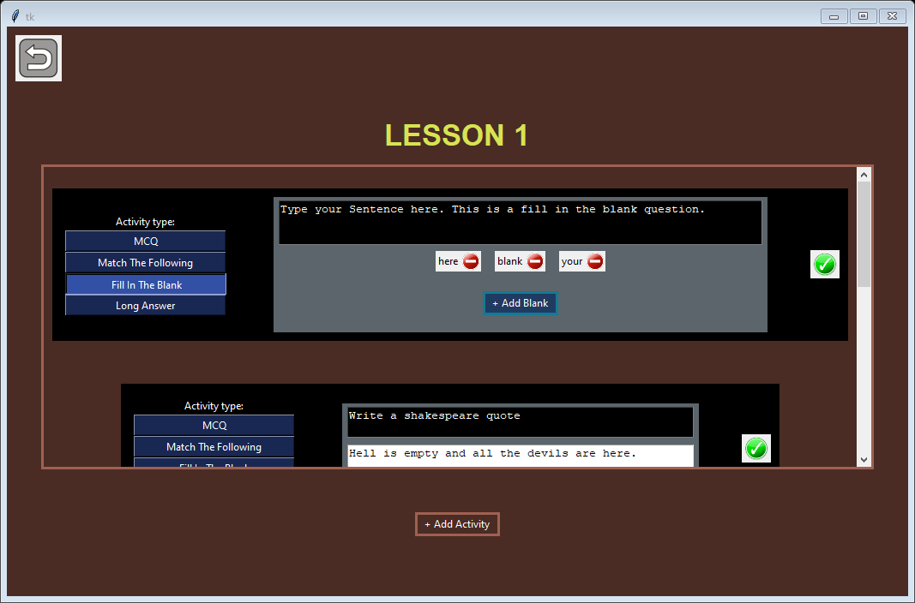

1. Generally, in Activities, there are 4 types of Activities, that you can create as shown below(1).
2. When Finished, click on the Green tick mark to edit or done creating the activity (2).
3. This is a fill in the Blank activity, so you can add Blanks or remove previously added blanks. When you click Add blanks, just hover over to any word and click on it. Blanks can be removed by clicking on the corresponding Blank’s box.
4. Use Side scroll bars to scroll down to any Activity.
5. Click the button on Top Left to go back to home screen.
6. Click the Done button(2) to collapse any activity as shown below.

1. In the Collapsed form of the Activity, you can edit Name(1) and you can re-visit the activity to edit(2).